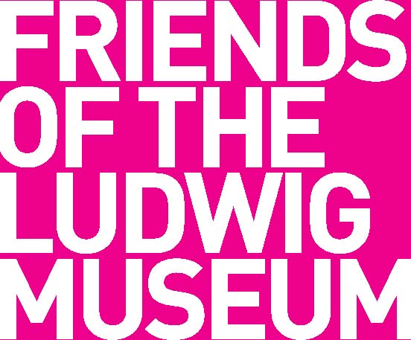 | FRIENDS OF THE LUDWIG MUSEUM  Member Application Form
Name: .................................................................................................................................
E-mail address: ..................................................................................................................
Postal address: ...................................................................................................................
Phone number: ..................................................................................................................
- The registered, non-transferable Membership Card is valid for its owner plus one extra person.

- Within the validity period, Membership Card Owner and their partner can visit all the exhibitions and events at the Museum for free.
- Membership Card Owner and their partner get free entrance tickets for each admission.
- For each admission, Membership Card and a valid personal document should be presented at the museum’s box office, where Your free tickets are to be issued with priority.

Please select the membership category you would like to choose.*
*For more information about membership categories, visit www.ludwigmuseum.hu.
€ Personal membership € VIP membership € Corporate membership
Please choose the activity/activities you would like to support with your contribution from the list below.

- Museum education programmes
- Buying artworks – expanding the Museum’s Collection
- Events in connection with the temporary exhibitions

Budapest, ..………………. ……………………
Date Signature

